Andrew Pham

Douglas Enos

December 3, 2018

Multimedia & Interact Web Elements 801

Final Project Documentation

The goal of the site is to provide users a site to learn multiple coding languages without consistently searching and using multiple sites. The site (at the moment) provides introductory lessons to 3 different languages: C, Java and Python; and allows users to try coding examples themselves at the bottom of the screen.

The lessons that were used on our project website derived from the coding books, “Starting out with Java from Control Structures through Objects” 6th Edition by Tony Gaddis and <https://www.w3schools.com/>.

Each language on the site has a unique flash animation for a print function. However, the same animation is used for the other lessons within that language. We did not have time to create 16 different animated flash elements; thus, the reason for the recycled animation clips. This was a proof of concept of what the site would look like and how it would operate.

Flash Animation #1: C print function

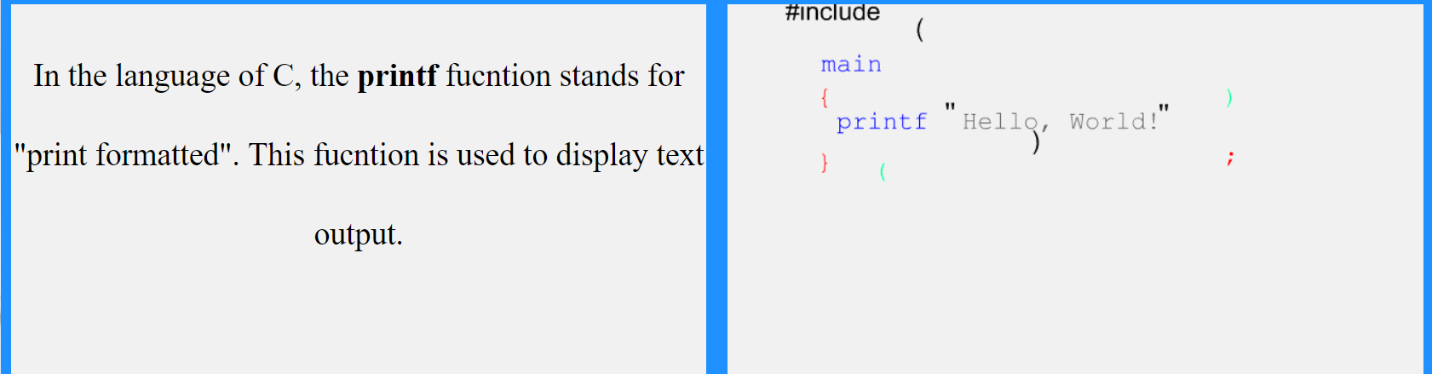

Flash Animation #2: Java print function

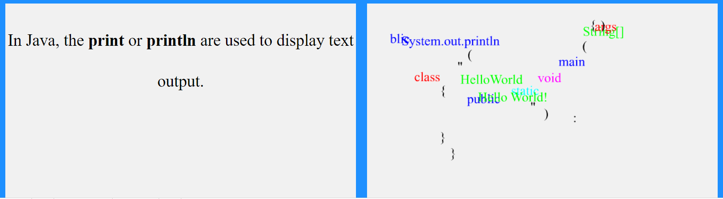

Flash Animation #3: Python print function

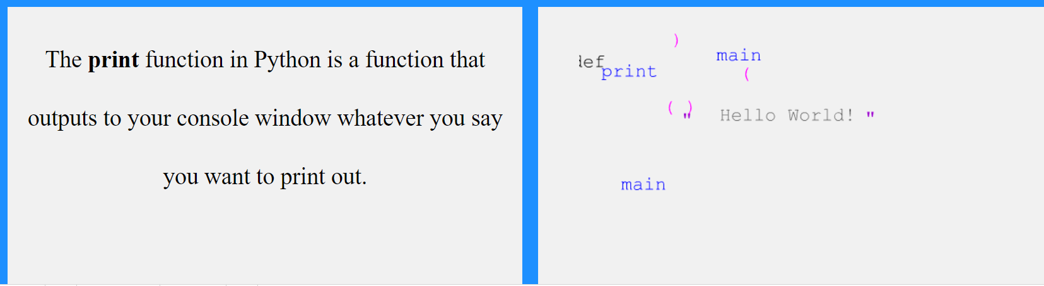

HTML Elements

Our project site mostly uses an external style sheet for the styling of the entire site. While there are a few internal style elements to override the global styling to achieve our goals. In our subscribe link on our About page, a form, constructed from a table, is used to receive users’ input of their name and email. There were many Divs used to separate the side navigation and the content of the flexbox.